**Question 1:**

**Aim:** To create a bootloader with a blank screen

**Code:**

[BITS 16]

[ORG 0x7C00]

JMP $

TIMES 510-($-$$) db 0

DW 0xAA55

**Step 1:** Image created

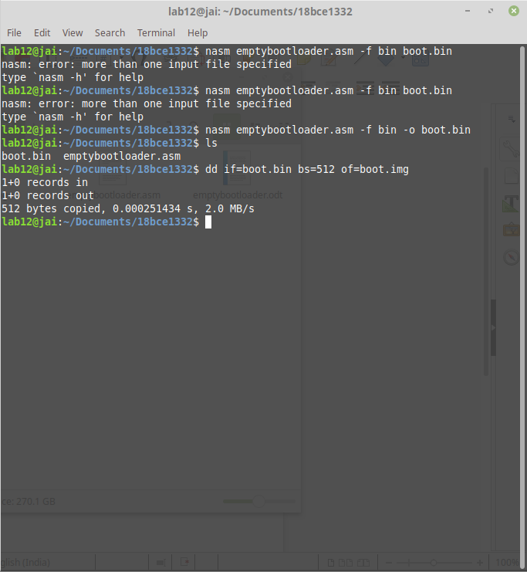

**Step 2:**Virtual Machine created



**Step 3:** Attach image to the system

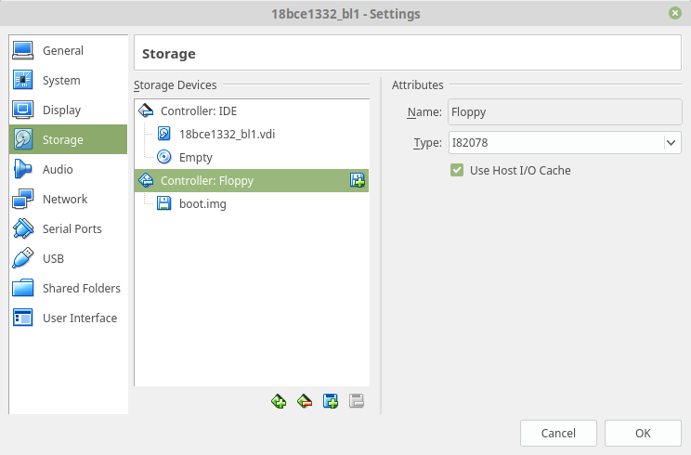**Step 5: Final Output**

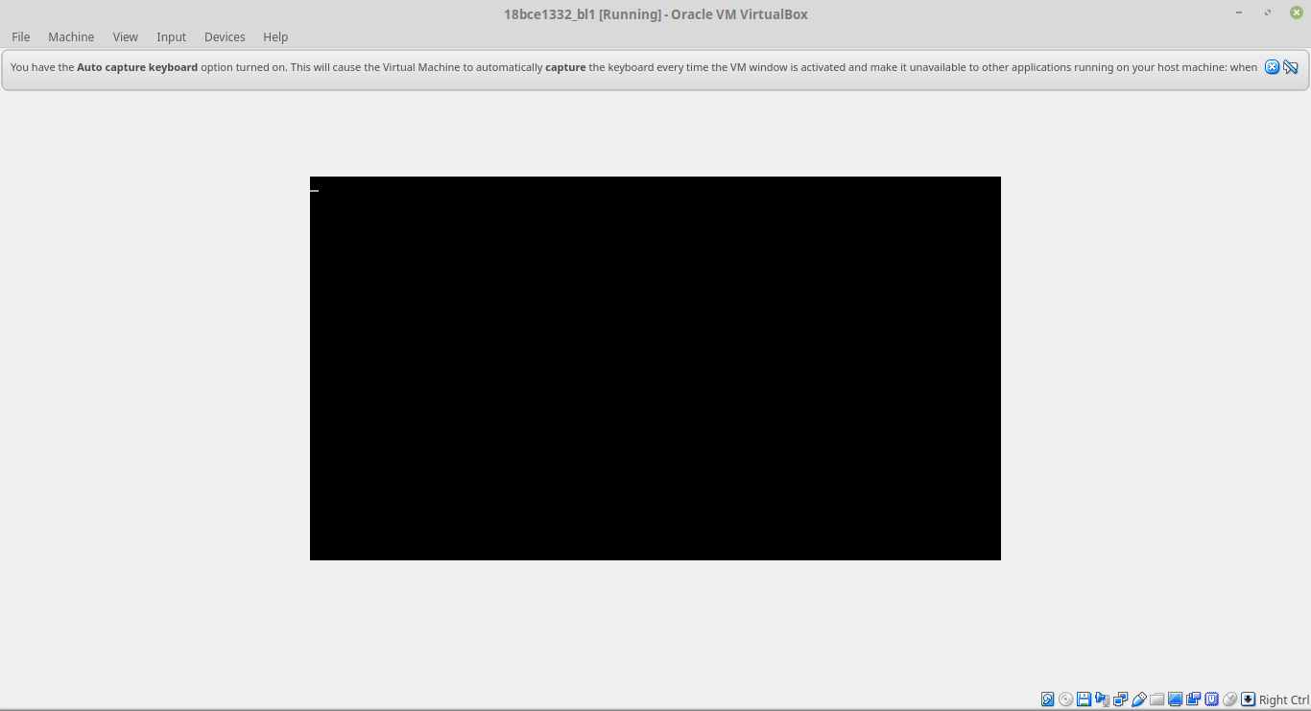

**Question 2:**

**Aim:** To create a bootloader which prints a letter on screen

**Code:**

[BITS 16]

[ORG 0x7C00]

MOV AL,74

CALL PrintCharacter

JMP $

PrintCharacter:

MOV AH,0x0E

MOV BH,0x00

MOV BL,0x07

INT 0x10

RET

TIMES 510-($-$$) db 0

DW 0xAA55

**Screenshot:**

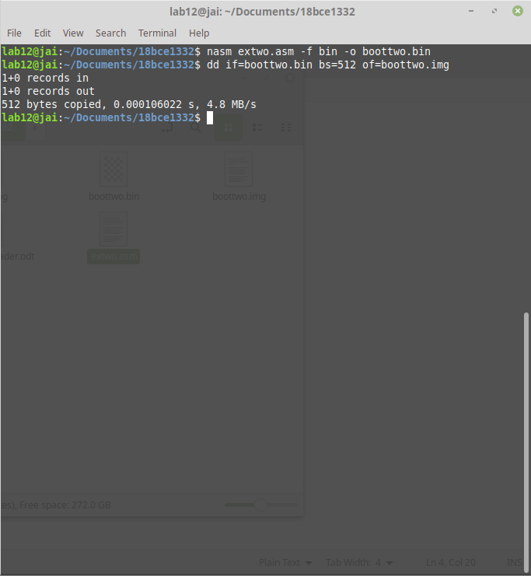**1.Created image file**

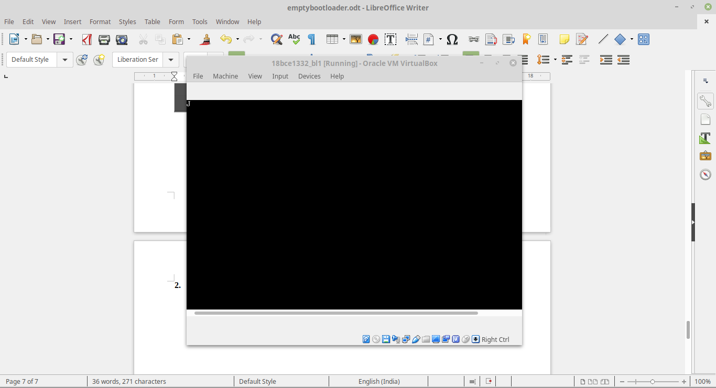**2.Final output**